Copyright Anomaly Detection using Blockchain

In existing application we were heavily dependent on centralized or cloud servers to maintain copyright or any other important data but all those systems can be easily tamper by database administrator or can take copy of those data and leak to 3rd party users by accepting some bribes. In those system to detect anomaly or similar content or for verification we need to take help of 3rd party verification tool which will verify weather file saved in those server are protected or not.

Maintaining 3rd party tool for verification may put extra charges burden on user and to overcome from above issues we are employing Blockchain technology which has inbuilt support for Decentralized, encrypted and tamper proof data storage without requiring any 3rd party verification tool.

Blockchain store each record as block/transaction and associate each block with unique hashcode and this hashcode will get verify for next subsequent block storage, if any block data tamper then it will result into different hash and data tamper will get detected.

Propose work will not allow any copyright or duplicate or similar data to store in Blockchain. Propose work utilizing Isolation forest algorithm which will check hashes of prior and current file and if similarity detected then file will be marked as Anomaly and will not get stored in Blockchain.

Blockchain Ethereum can store or retrieve data using Smart Contract which can be designed using Solidity programming. This contract contains functions which can be called to save or retrieve data from Blockchain. To maintain copyright data we have designed following smart contract

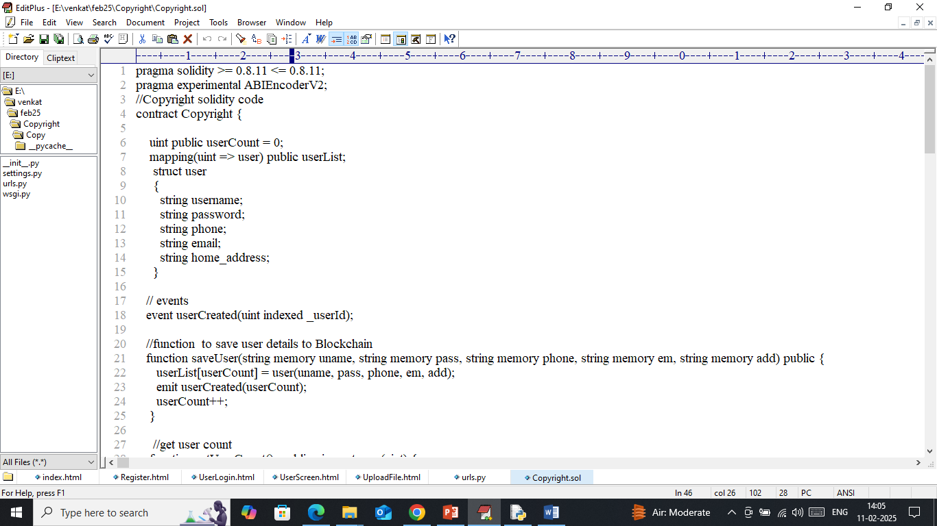

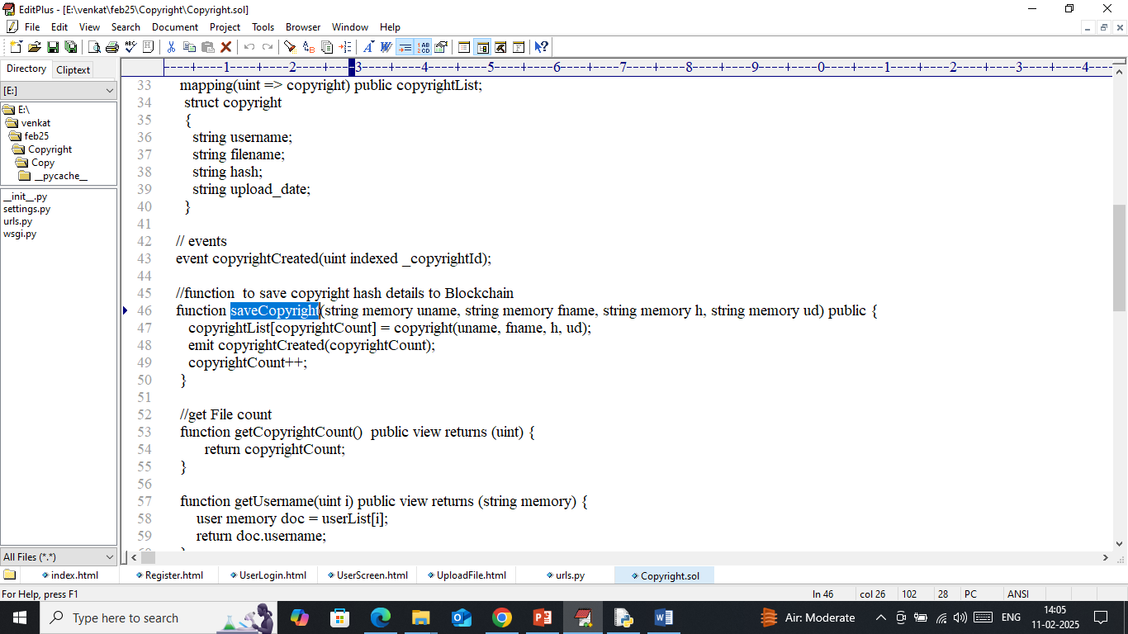

In above contract we have designed function to save user and their copyright files to Blockchain. User can save any type of file hashes such as Text, Images, audio etc. Now we need to deploy above contract to Blockchain Ethereum using below steps

1. First go inside ‘hello-eth/node-modules/bin’ folder and then look and double click on ‘runBlockchain.bat’ file to get below page
2. 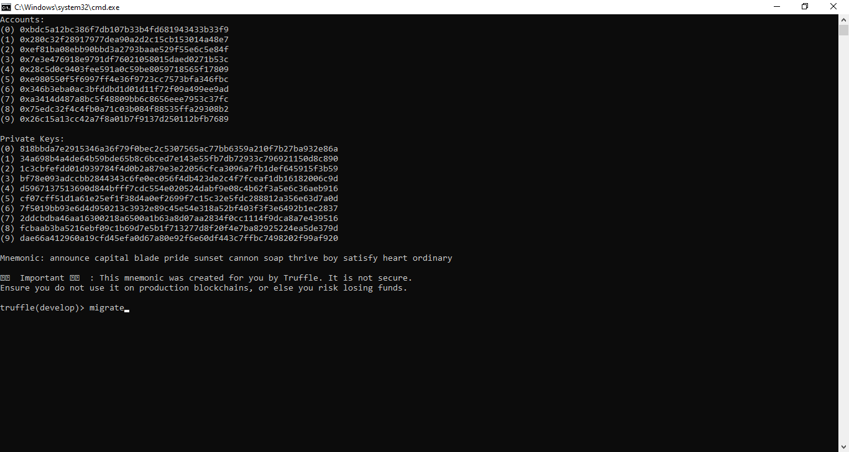
3. In above screen Ethereum started with default accounts and private keys and now type command as ‘migrate’ and then press enter key to get below page
4. 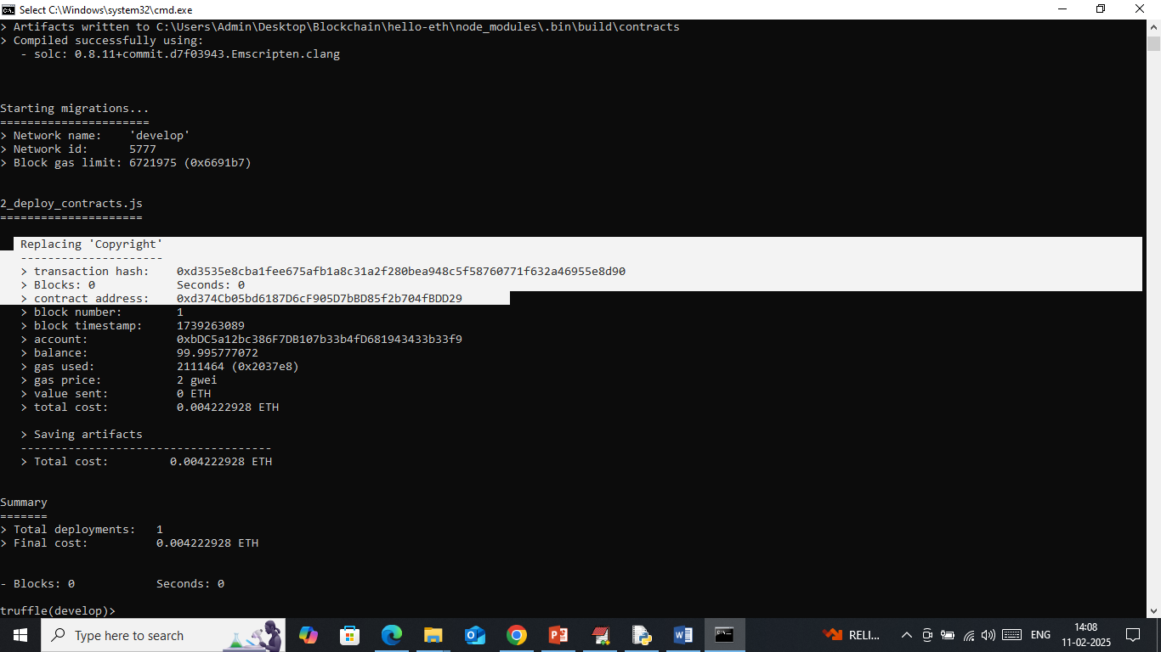
5. In above screen ‘Copyright’ contract deployed in Blockchain and got contract address also and this address we can specify in python program to call above contract to save and retrieve Copyright data. In below screen showing python code calling above contract using address
6. 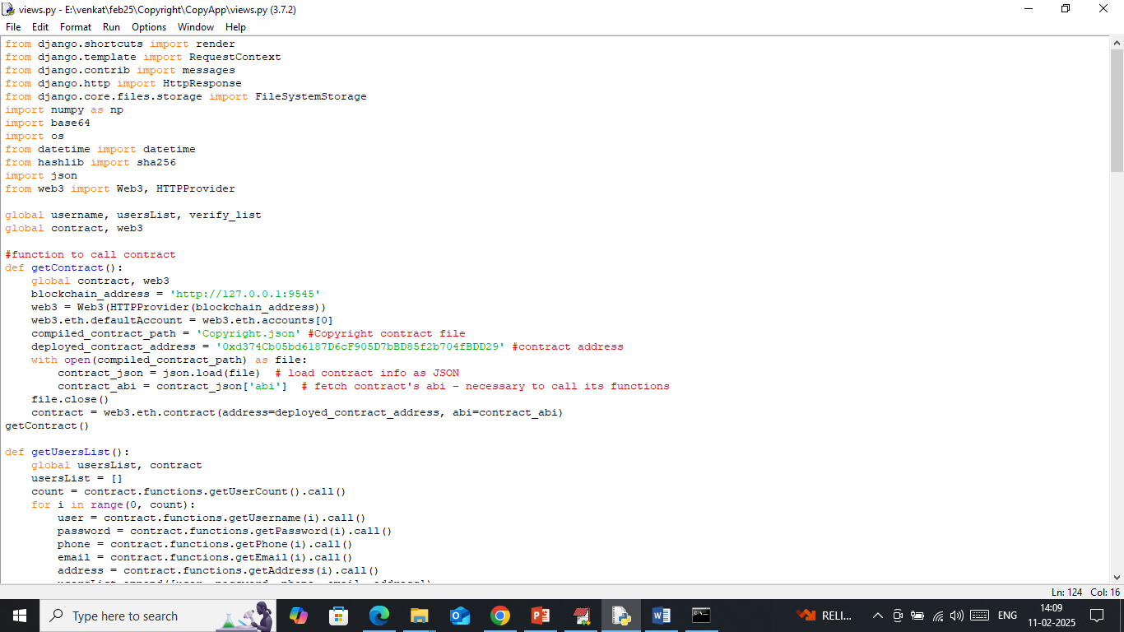
7. In above screen read red colour comments to know about contract calling using Blockchain address. In above screen we have deployed contract and running successfully and let it run till you execute code.

Modules Information

To implement this project we have designed following modules

1. New user sign up: using this module user can sign up with the application. All sign up details will get saved in Blockchain
2. User Login: using this module user can login to system and all user get authenticated via Blockchain
3. Upload Copyright Data to Blockchain: using this module user can upload any type of data to Blockchain. If any fraud user try to upload same data by copying others data then Blockchain hashes will get verify using Anomaly detected model, if same hashes detected then Blockchain will not allow user to save this file
4. ML Anomaly Verify Copyright: anytime user will run this module to check his file data verification with Blockchain hashes
5. Download Data: using this module user can view list of his uploaded files and can download desired file.

SCREEN SHOTS

To run project double click on ‘run.bat’ file to start python server and get below page

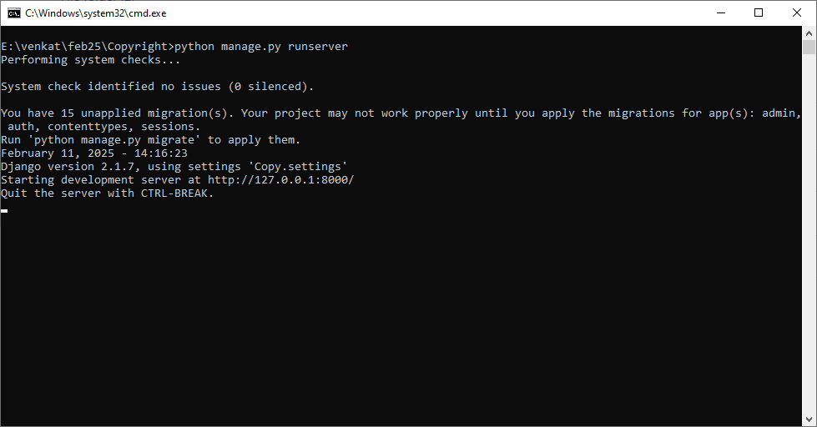

In above screen python server started and now open browser and enter URL as <http://127.0.0.1:8000/index.html> and then press enter key to get below page

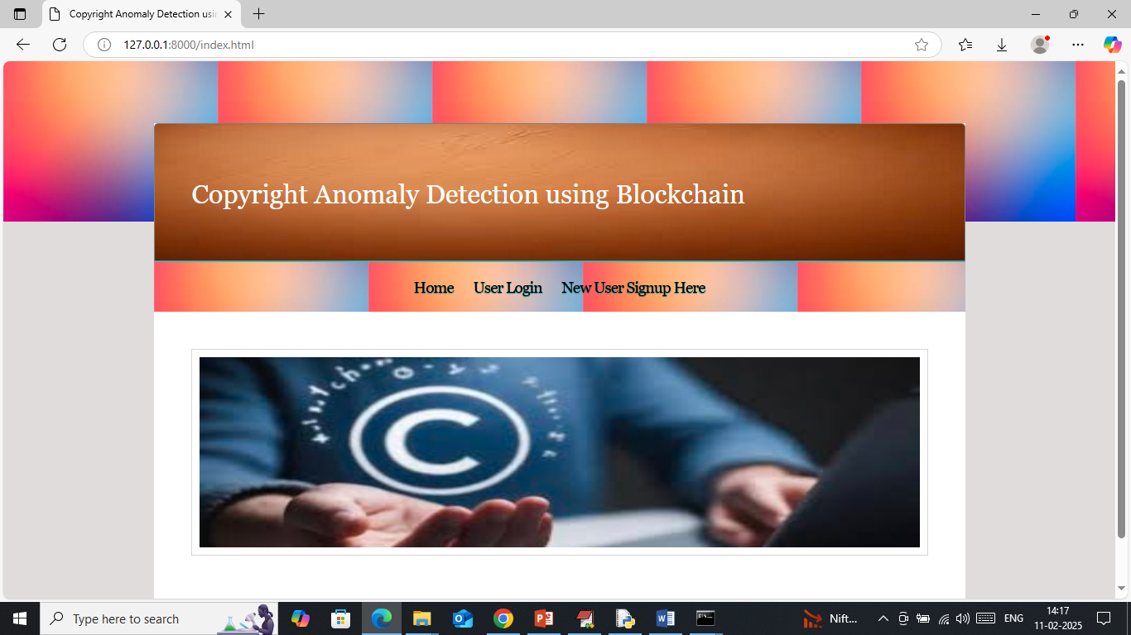

In above screen click on ‘New User Sign up’ link to get below page

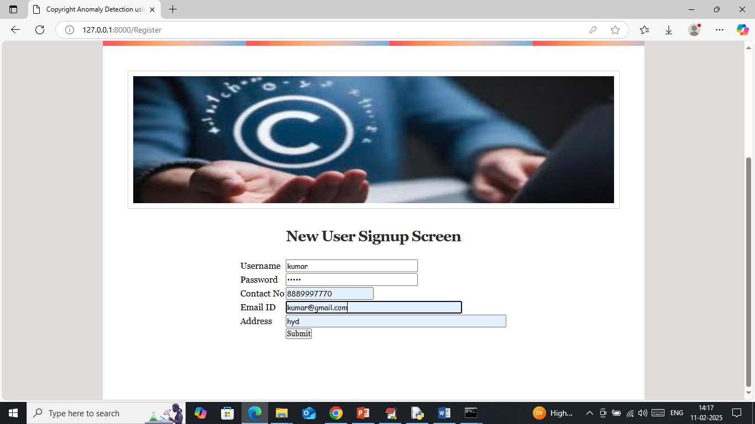

In above screen user is entering sign up details and then press button to get below page

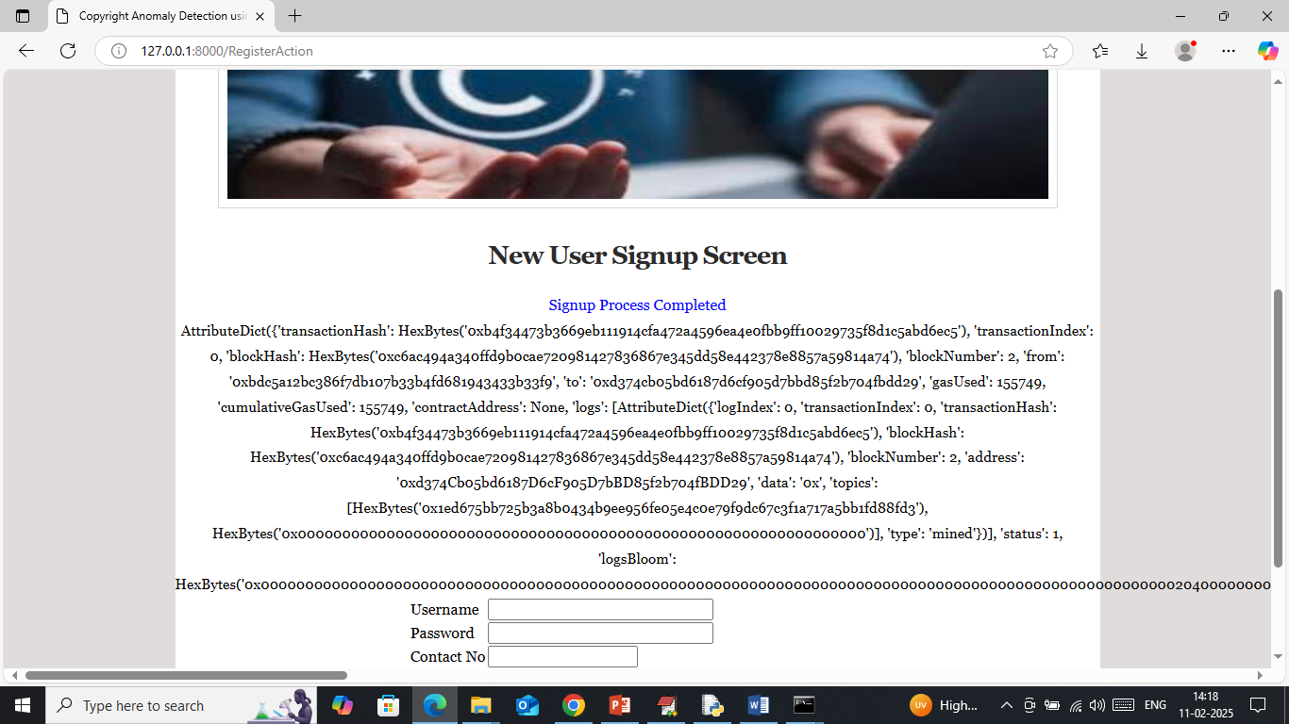

In above screen user sign up completed and this details saved in Blockchain and then I am displaying all log details obtained from Blockchain after storage. This log contains details like Block no, hash code, transaction no and many other details. Similarly you can sign up as many users as you want. Now click on ‘User Login’ link to get below page

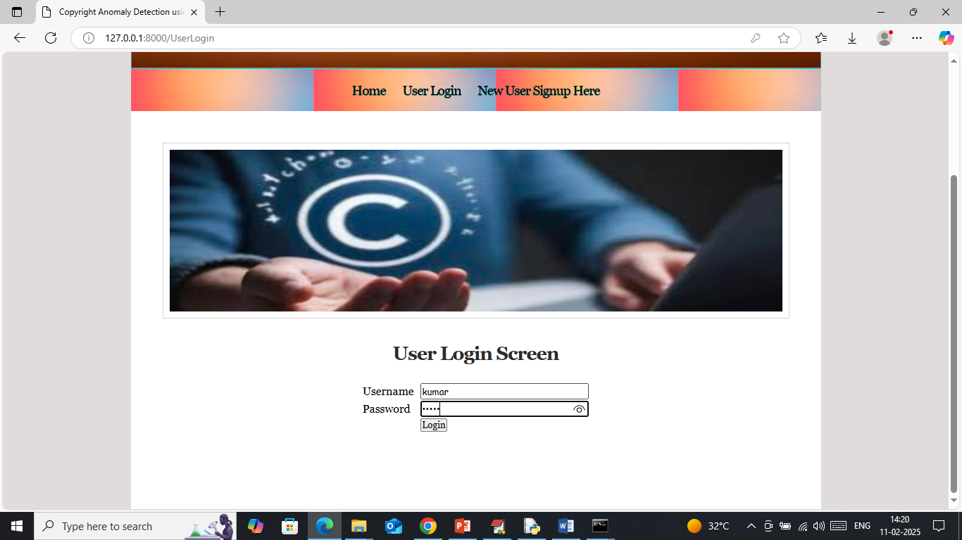

In above screen user is login and after login will get below page

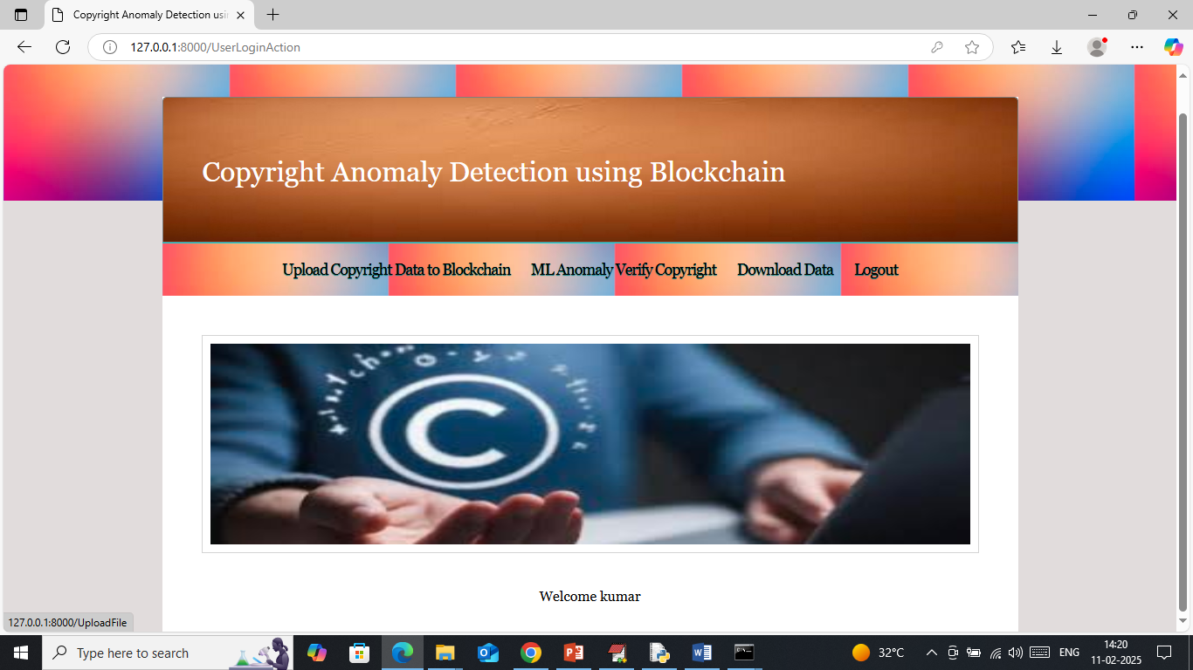

In above screen user can click on ‘Upload Copyright to Blockchain’ link to get below page

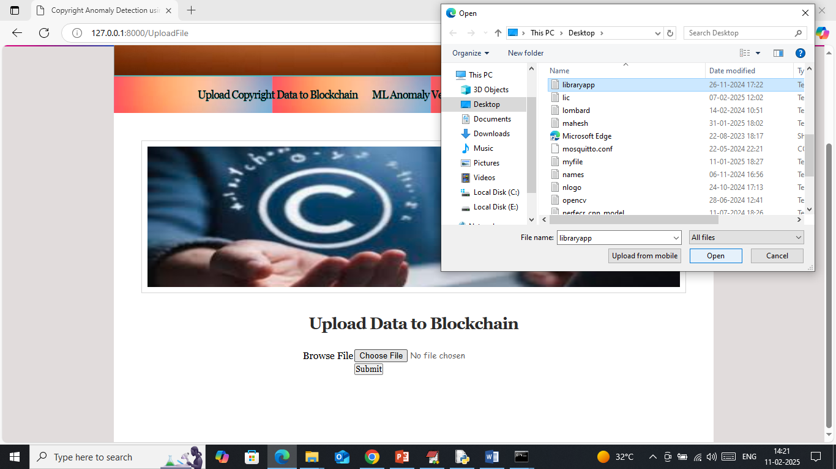

In above screen user can select and upload any type of data and then press buttons to get below page

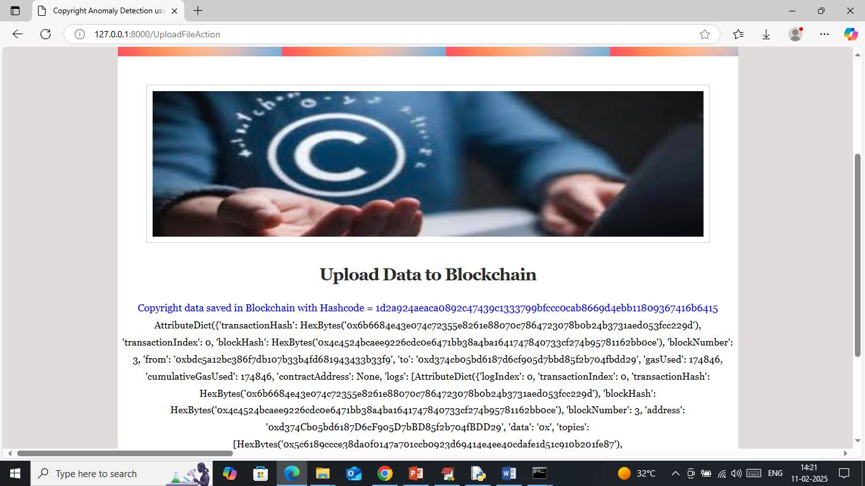

In above screen file details saved in Blockchain along with file hashcode and if same file try to upload by other user will get below page

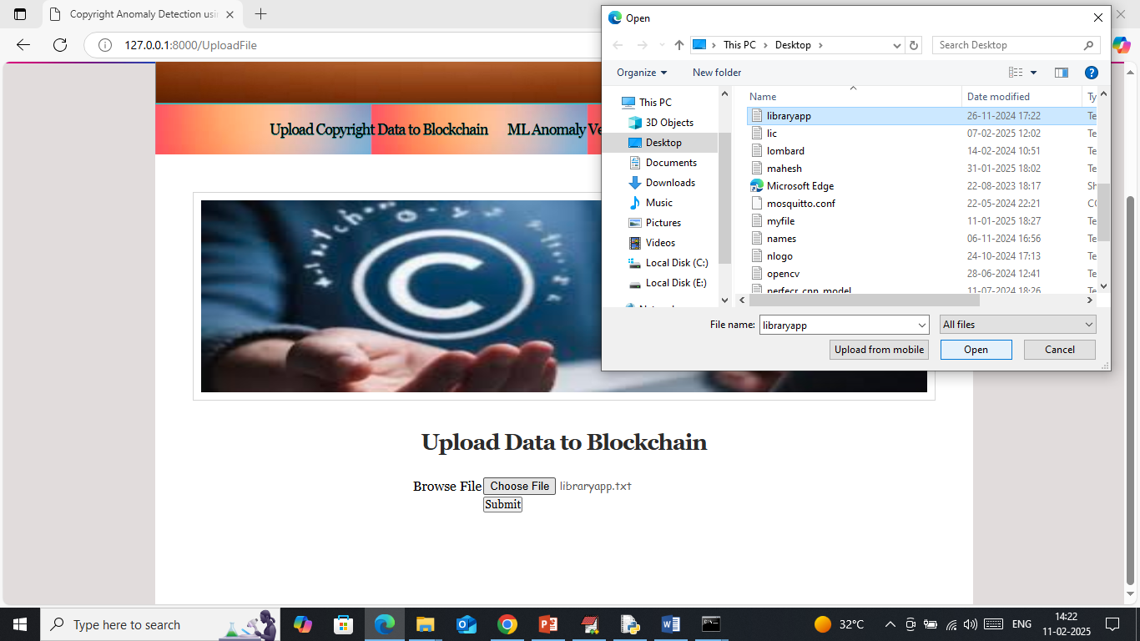

In above screen file with same content trying to upload and then press buttons to get below page

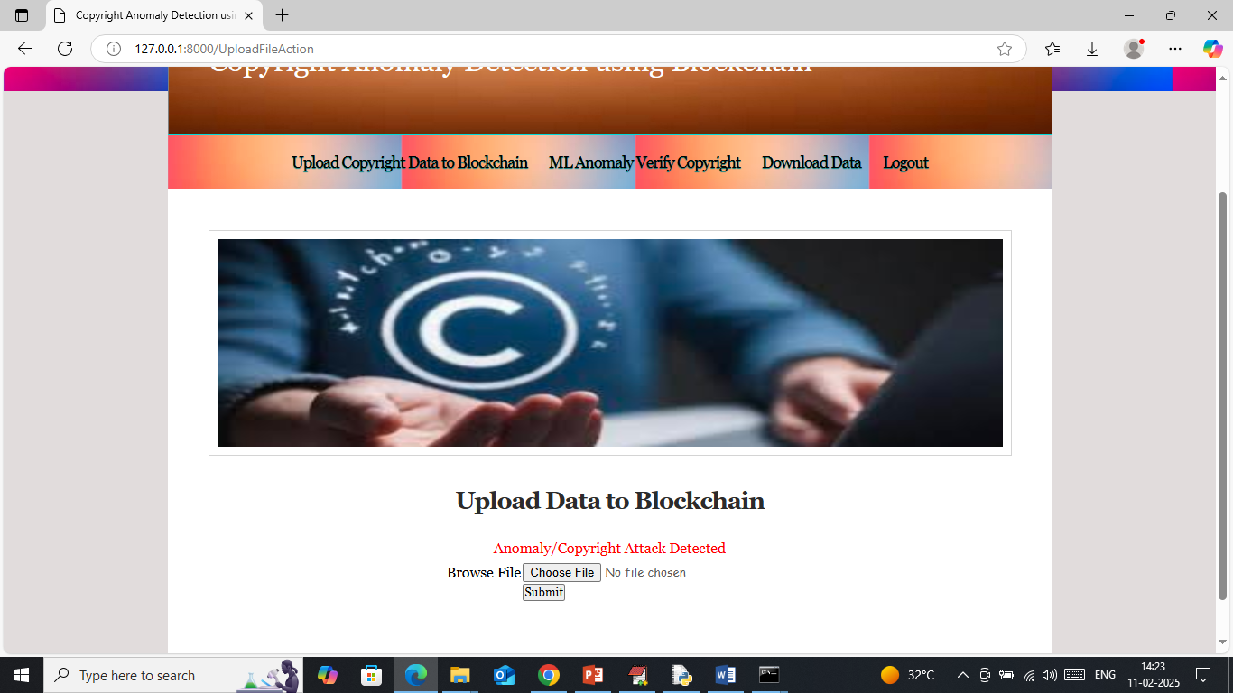

In above screen Blockchain detected copyright attack and this file not get saved and now click on ‘ML Anomaly Verify’ link to verify all files hashes to detect anomaly

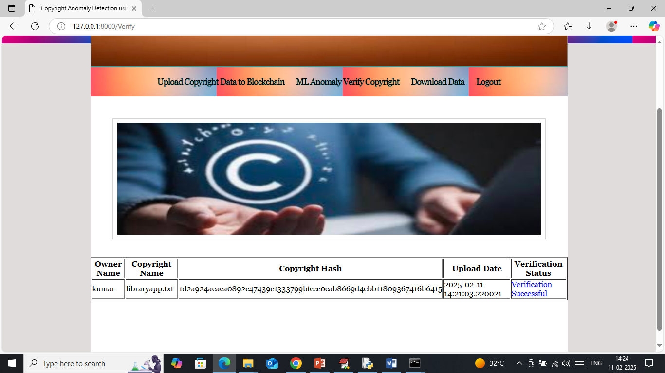

In above screen no anomaly or data tamper detected so file verification successful and now click on ‘Download Data’ link to view list of data and can download desired file

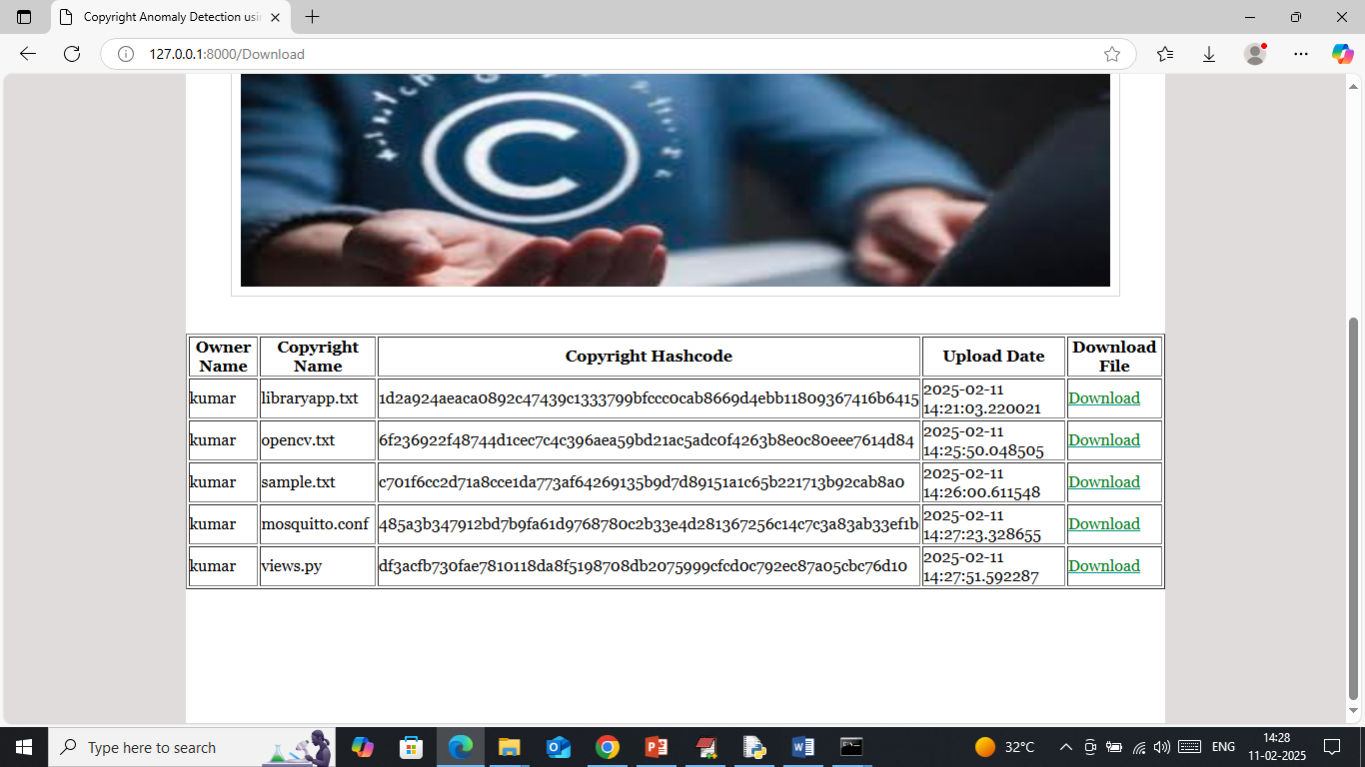

In above screen you can see list of uploaded copyright files and can click on ‘Download’ link to download desired file and get below page

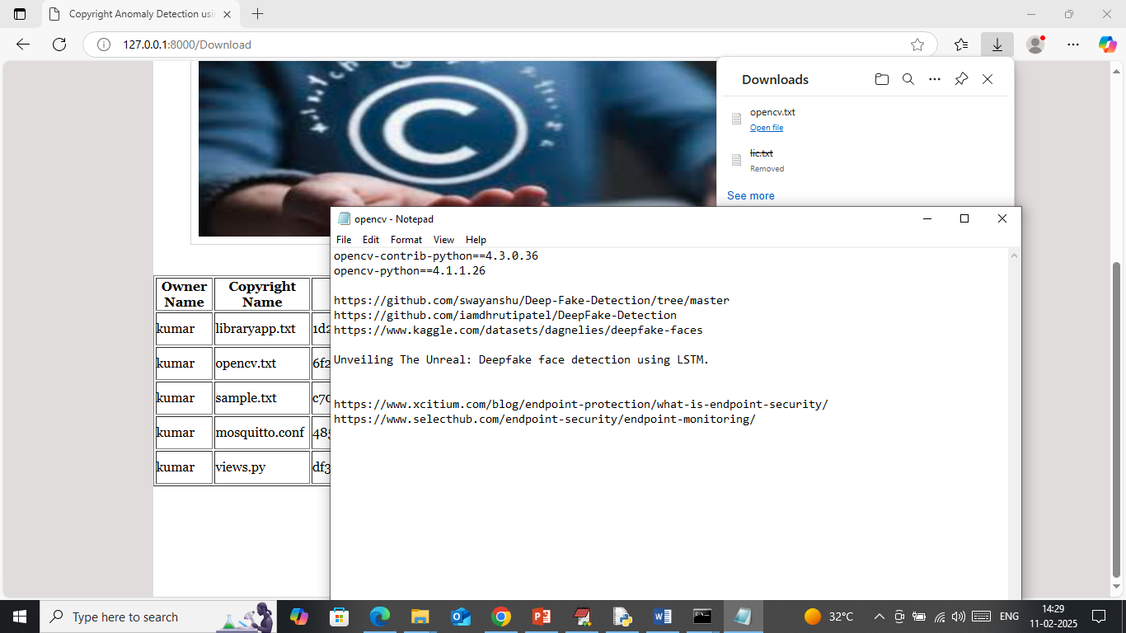

In above screen file is downloaded and can see the content of the file.

Similarly you can manage all copyright data securely in Blockchain without getting copy or leak or tamper.